OFF Duty rates for Airlines at Scandic Hotels, D000035587

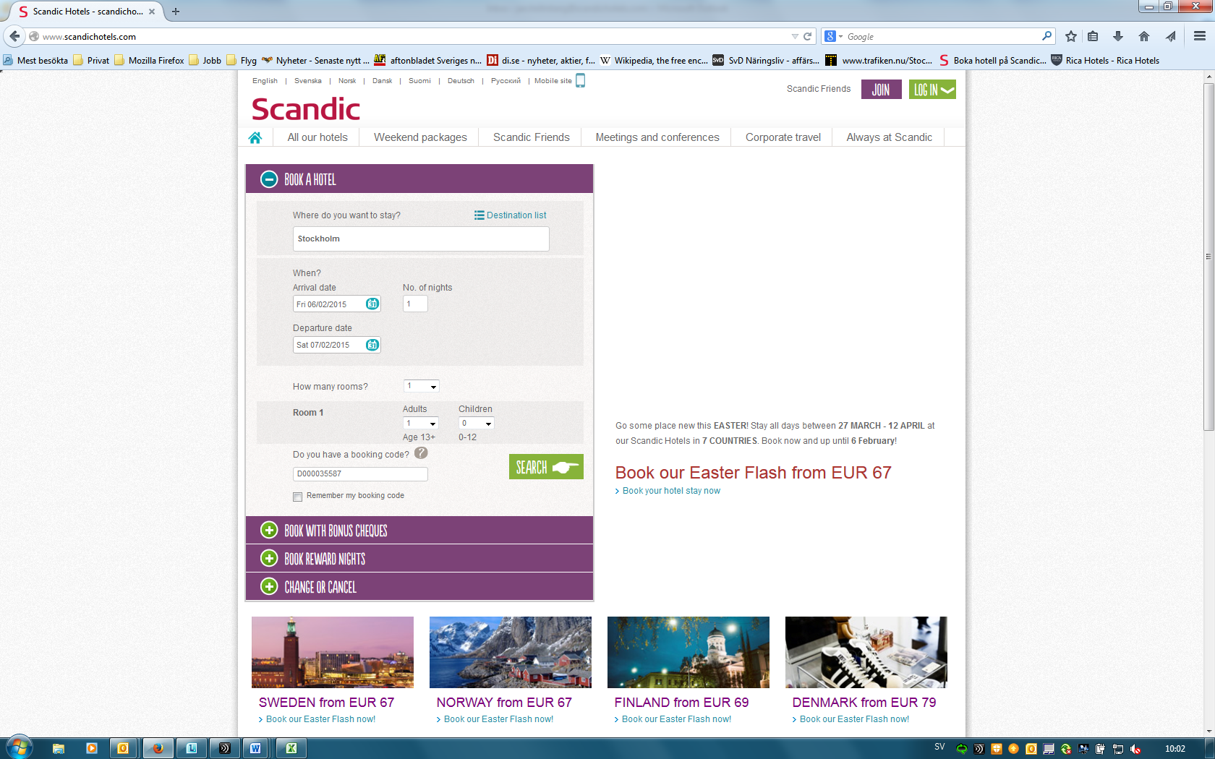
Use Scandic webpage, www.scandichotels.com, the webpages are also available in languages, Swedish, Norwegian, Danish, Finnish and German amongst others.
Search hotel by location or by specific hotel, fill in also agreement number D000035587, dates, number of persons. Lastly press search.

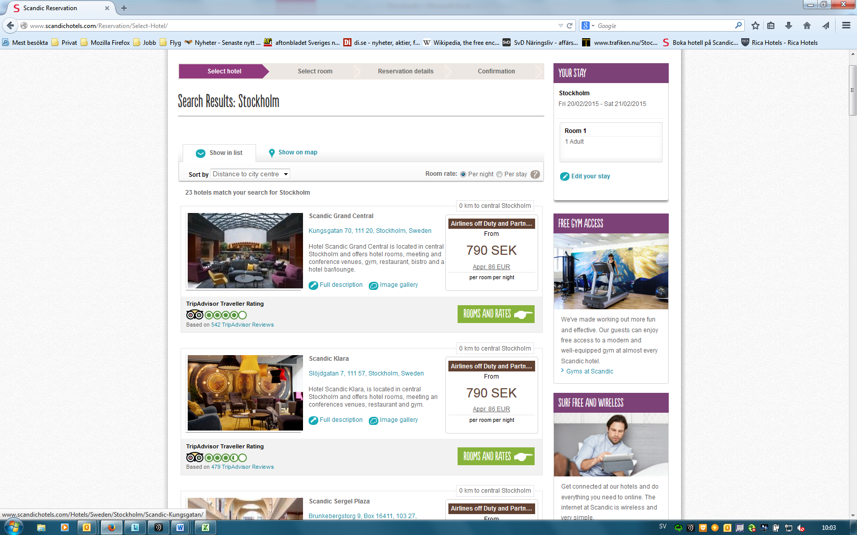
You will notice the rates that come up are written in Airline off duty and partner rate. Press room and rates for specific hotel.

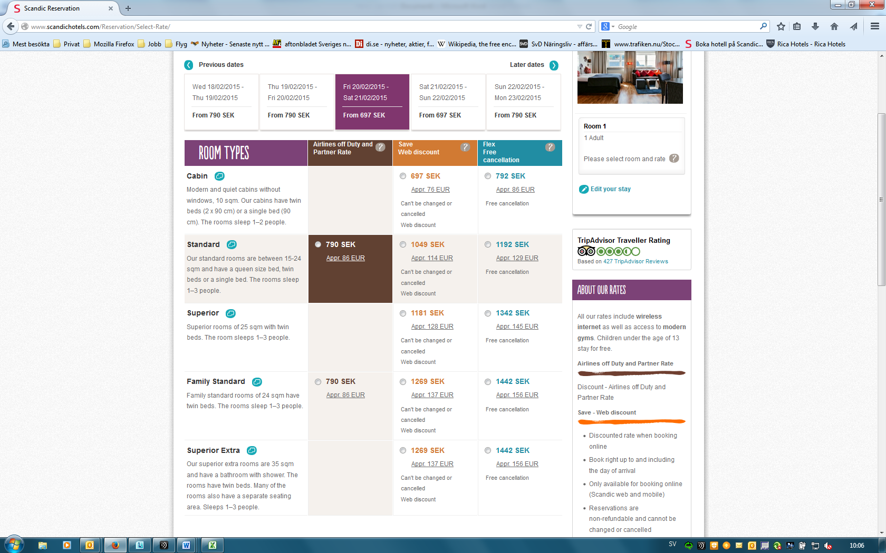
At room rate choose available room type and then continue.

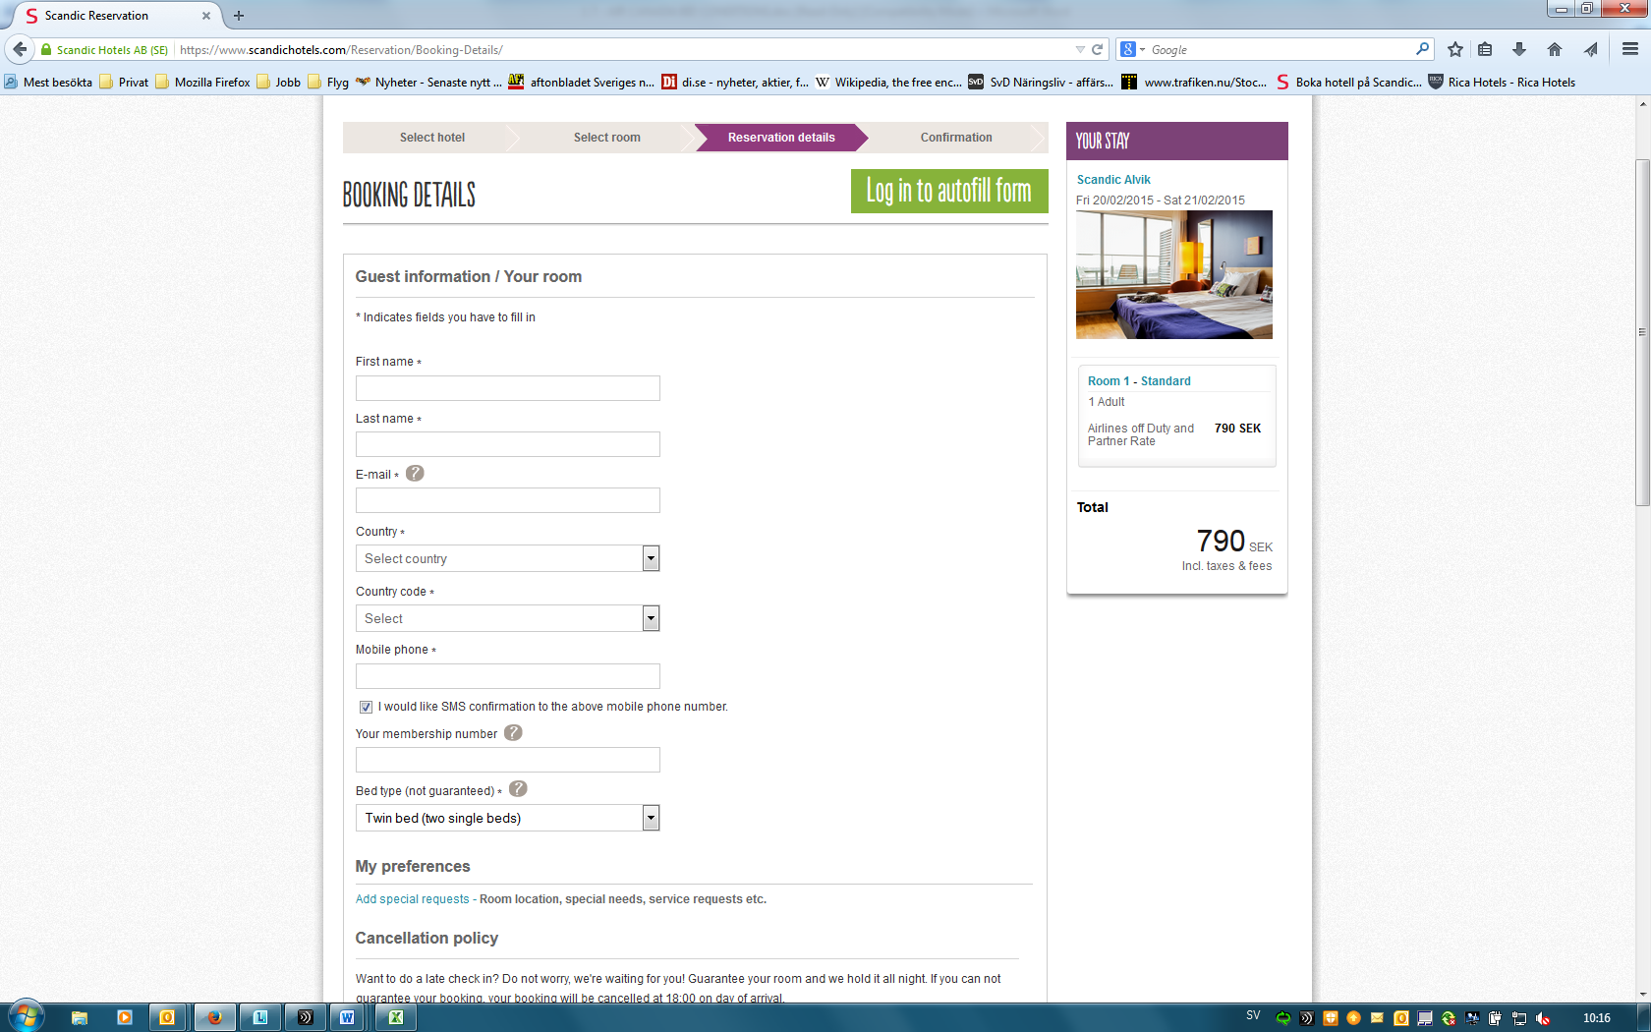
Add all booking details, and then everything is done.
Welcome to Scandic Hotels!!!

